2023
Florida Conference of Historians
Annual Meeting

January 27-29, 2023

Marriott Hutchinson Island Beach Resort, Golf and Marina
Stuart, Florida

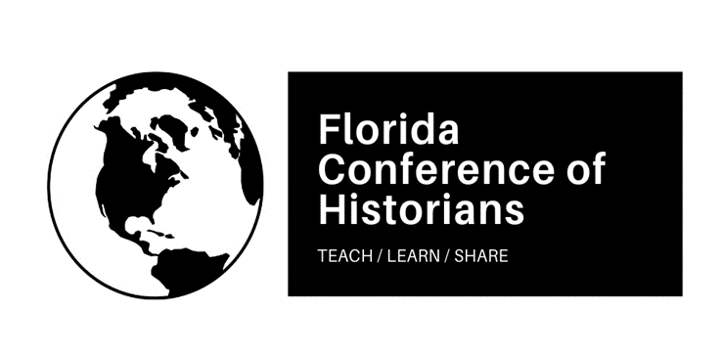
Hosted by Indian River State College
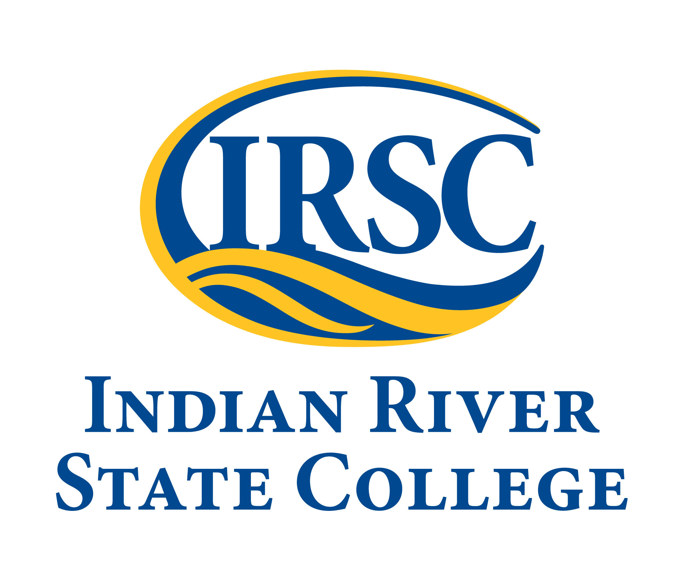

Local Arrangements and Program Co-Chairs

Beau Driver
Indian River State College

J. Brian Freeman
Indian River State College

Jesse Hingson
Jacksonville University

Officers of the
Florida Conference of Historians, 2023-2024

Co-Presidents Beau Driver and J. Brian Freeman
Indian River State College

President-Elect Ilana Grimes
Eastern Florida State College

Secretary David Proctor
Tallahassee Community College

Treasurer Jesse Hingson
Jacksonville University

FCH Annals:
The Journal of the Florida Conference of Historians
Senior Editor
Michael S. Cole
Florida Gulf Coast University

MAP OF MARRIOTT HUTCHINSON ISLAND BEACH RESORT, GOLF AND MARINA
CONFERENCE CENTER (SECOND FLOOR)

- Saturday panels will take place in the meeting rooms: McCoy, Menninger, Evinrude, Monroe, and Sewall
- Saturday evening banquet, awards presentations, and keynote will take place in the Plantation Ballroom

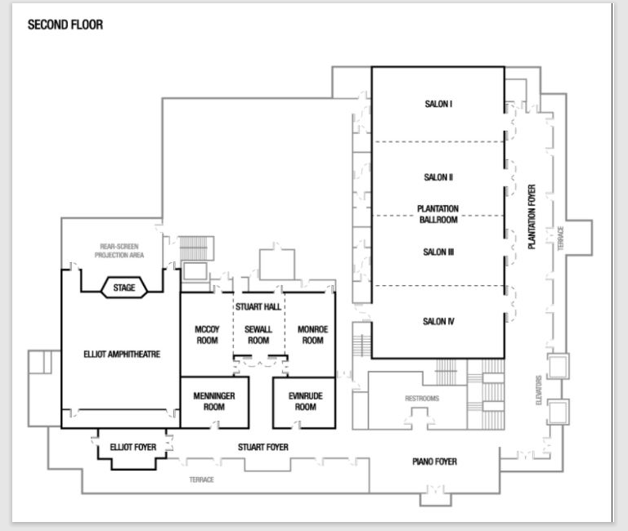

Friday, January 27, 2023

5:30 PM-7:00 PM:
Welcome Reception
Appetizers and Refreshments
Cash Bar

Location:
Covered Patio located next to Latitudes by the Main Hotel Pool

FCH Registration Available

Agenda:
Update on Civic Literacy
David Proctor, Tallahassee Community College

Saturday, January 28, 2023

8:30 AM-4:00 PM: Registration
Location: Piano Foyer
Coffee and Refreshment Break, 10:00 AM-10:45 AM

Session One: Saturday, 9:00 AM-10:15 AM
Panel 1A: Ground-Breaking Studies in Women’s History
Special Interest Section: Undergraduate Research
Meeting Room: Menninger

Centennial Commemorations of Women Martyrs in the
Spanish American Wars of Independence
Tatiana Addonizio, Jacksonville University

Between National Politics and Gender Traditions: Women’s Public Higher Education in Early Twentieth-Century China
Lisa Hyde, New College of Florida

The Ideal Facade: The Double Standard of Elite Nazi Women in Their Ascent to Power
Chloe Carver, Southeastern University

Chair and Discussant: Ilana Grimes, Eastern Florida State College

Panel 1B: Social Movements and Activism during
the Civil Rights Era
Meeting Room: Sewall

Women Journalists Guiding Their Communities:
Newspaper Advice Columns, 1940s Through 1970s
Kimberly Voss, University of Central Florida

When the Looting Starts, the Shooting Starts:
The 1968 Miami Uprising
Seth Weitz, Dalton State College

“Nor will we be denied control over our own university”:
Campus Activism, Women’s Liberation, and Politics
in 1970s Texas
Jillian McClure, University of North Florida

Chair and Discussant: Blaine Browne, Broward College (Emeritus)
Panel 1C: Studies in Southern History
Meeting Room: Monroe

Race, Rights, and Region: Indigenous Women Enslavers and White Women’s Civic Culture in the Deep South, 1830s-1930s
Justin Rogers, University of North Florida

The Petition of Certain Non-Conscripts: An Effort to Challenge Conscription in the Confederate States of America
Victoria Stewart, Northwest Florida State College

Politicizing National Memory: How Civil War Imagery, Rhetoric, and Performance Defined the Culture Wars
John Lancaster, University of Central Florida

Chair: Don Zimmerman, Indian River State College
Discussant: David Proctor, Tallahassee Community College

Panel 1D: The Pursuit of Excellence in the Classroom and Beyond: The History Program at Flagler College
Special Interest Section: Scholarship of Teaching and Learning
Meeting Room: Evinrude

Nic Miller
John Young
Kelly Enright
Mike Butler
Jessica Howell

Panel 1E: The Distant Global Past
Special Interest Section: Undergraduate Research
Meeting Room: McCoy

Perceptions of Chivalry on the Modern College Campus
Logan Harris, Southeastern University

Lorenzo the Magnificent: The Making of a Powerful Patron
Carmyn Schneider, Florida Southern College

Trading Companies of the East Indies, Traders turned Colonizers, and Imperialism’s Most Famous Scapegoats
Michael Rothstein, Florida Southern College

Chair and Discussant: Rowena Múzquiz,
St. Vincent de Paul Regional Seminary
Session Two: Saturday, 10:30 AM-11:45 AM
Panel 2A: Africa, Development, and State-Building
Meeting Room: Menninger

“Somewhat Decrepit”? Mining, Monopoly and Distorted Development in Obuase, Ghana (1897-1957)
Frimpong Asamoah, University of Miami

“We merely passed through”: Border Controls for Africans and Their Implementation in Colonial Zanzibar, 1920-1960
Charlotte Miller, Middle Georgia State University

“Between the ‘House Nkrumah Built’ and the ‘House the IMF Built’”: Students and Popular Political Protest in
Gold Coast and Ghana, 1950-2000
Edmund Abaka, University of Miami

Chair and Discussant: Alex Shelby, Indian River State College

Panel 2B: Systems of Submission in the Age of Revolution
Special Interest Section: Undergraduate Research
Meeting Room: Evinrude

The Mundanity of Religion and the Deification of Rousseau in
Pre-Revolutionary France
Savana Walters, Southeastern University

Slavery on the South Colonies
Marcos Ramos Ortega, University of Central Florida

Chair and Discussant: Douglas Benner,
University of South Florida

Panel 2C: Visions of Florida and the Past
Special Interest Section: Florida History
Meeting Room: McCoy

Creating an Exotic Tropicality: Design, Architecture, and Communication in the Mid-Century
Florida Beach Hotel Experience
Mike Walker, University of Florida

The Florida Frontier on Film and Television in the 20th Century
David Morton, University of Central Florida

Chair and Discussant: Marvin Hobson, Indian River State College

Panel 2D: Contested Claims:
New Scholarship and the ‘Settling’ of the American Continent
Meeting Room: Sewall

Indigenous Genocide in America
Maverick Huneycutt, University of North Carolina at Charlotte

Early America Cartography
Jared Freedline, University of Central Florida

Indigenizing the North American Academy: Resistance & Rethinking Colonial Practices in Academia through Indigenous Storytelling & Allyship
Emma Posca, York University-Toronto Canada

Chair and Discussant: Kaitlyn Shefveland, University of Southern Indiana

Panel 2E: Critical Junctures and Social Movements in the Twentieth Century
Meeting Room: Monroe

A Clearing House:
Lou Henry Hoover’s Great Depression Relief Letter System, 1931
Presleigh Johnson, Flagler College

“White People, Inc.”, Bryant W. Bowles, White Populism, and Political Consciousness, 1952-1960
Liam King, Rollins College

“Like a strange dog in an alley”:
Social Perceptions of Epilepsy and the Question of Human Rights
Marisa Pechillo, University of North Florida

Chair: Jared Kinggard, Indian River State College
Discussant: Michael Epple, Florida Gulf Coast University

12:00 PM-1:00 PM: LUNCH BREAK ON YOUR OWN
Onsite options
- Baha Grille Full-service restaurant
- Sandpiper Tiki Bar Serving cocktails, sandwiches, salads.

Offsite options within 3 miles
- Bagel Break Deli 2395 SE Ocean Blvd, Stuart, FL 34996
- Ramen Hana & Sushi 2661 SE Ocean Blvd, Stuart, FL 34996
- Aunt D's Diner 2891 SE Ocean Blvd, Stuart, FL 34996

FCH BUSINESS MEETING
- Meeting Room: Sandpiper Tiki Bar
- FCH Officers
Session Three: Saturday, 1:00 PM-2:15 PM
Panel 3A: Alternative Ways of Presenting the Past
Special Interest Section: Undergraduate Research
Meeting Room: Evinrude
NOTE: Authors will be available to discuss their projects.

Poster Presentation:
Temperance and Templars: The International Order of Good Templars and the Rise of Prohibition, 1852-1932
Grant Dorshimer, Jacksonville University

Media Presentation:
Craig and Barbara Weiner Holocaust Reflection and
Resource Center
Nicolas Farach, University of Central Florida

Chair: J. Brian Freeman, Indian River State College

Panel 3B: Innovative Studies on the New South
Meeting Room: Menninger

Italian American Gardens in Alabama
Rosetta Giuliani Caponetto, Auburn University

"It's Southern Heritage": The 2017 Confederate Monument Controversy and the Malleability of the Physical Landscape
Aaron Lewis, University of South Florida

Chair and Discussant: Jillian McClure,
University of North Florida

Panel 3C: Studies on the Middle East and Asia
Special Interest Section: Undergraduate Research
Meeting Room: McCoy

The Evolving Ideology of the Kurdistan Workers’ Party
Carsten Comberg, University of North Florida

Missiles, Men, and ARMISH MAAG: Examining the Importance of ARMISH MAAG on the Iran-Iraq War
Michael Schildberg, Florida Southern College

A Necessary Expansion of the Vietnam War Timeline:
United States Involvement in French-Indochina
Casandra McNulty, Flagler College

Chair and Discussant: Marco Rimanelli, Saint Leo University
Panel 3D: Sustainability in Central Florida: Food, Activism, and Restoration
Special Interest Section: Florida History
Meeting Room: Sewall

Florida's Approach to Food Waste:
A Brief History, Problems, and Potential Solutions
Grace Dearden, Oregon State University

Sustainability Showdown:
Its Origin and Implications at Rollins College
Julia Taylor, Rollins College

Community Sustainability: Winter Park's Genius Preserve
Leslie Poole, Rollins College

Chair and Discussant: Patricia Farless,
University of Central Florida

Panel 3E: Innovations in Sources and Historiography
Meeting Room: Monroe

Slow Disasters and Pandemic Archives: The Rolling-Response Model
Marissa Rhodes, Saint Leo University

Recetas: A Recipe for DH Web Publishing and
Content Management
Sarah Tew and Melissa Jerome, University of Florida

Written Culture and Historicity in the Historiography of Past & Present: An Evaluation of the Meanings of Writing History,
1952-1959
Nelson Aracena, Pontificia Universidad Católica de Valparaíso

Chair: Gerrianne Schaad, Florida Southern College
Discussant: Rowena Múzquiz, St. Vincent de Paul Regional Seminary

Session Four: Saturday, 2:30 PM-3:45 PM
Panel 4A: New Approaches to US Politics and Institutions
Meeting Room: Menninger

Seven Histories of the 1787 Constitution Convention
Mitchell Prugh, Independent Scholar

Rethinking Presidential Rankings
Constantinos Scaros, Colorado Technical University

Is the Party Over? Florida's Evolving--or Devolving--Voting Primaries and Their Consequences
Mary Adkins, University of Florida Levin College of Law

Chair and Discussant: Douglas Benner, University of South Florida

Panel 4B: Latin America and the Cold War
Special Interest Section: Undergraduate Research
Meeting Room: McCoy

Costa Rica's Peaceful Coexistence in a Militarized World
Grayson Aceto, Florida Gulf Coast University

Truth and Memory:
Public Representations of the US Role in Colombia's Civil War
Callum Kimbrough, Jacksonville University

Chair and Discussant: Jesse Hingson, Jacksonville University

Panel 4C: Environmental History of Florida
Special Interest Section: Florida History
Meeting Room: Sewall

One Step Forward, Two Steps Back:
Grassroots Campaigns to Protect Florida's St. Johns River
Charles Closmann, University of North Florida

Monkey Go Home?
The Battle Over the Monkeys of Silver River, 1970-1990
David Nelson, Abraham Baldwin Agricultural College-Bainbridge

Unbearable Neighbors:
An Analysis of Florida’s Black Bear Management Policies (1931-2015)
Zachary Weston, Independent Scholar

Chair: Sean McMahon, Florida Gateway College
Discussant: Nathaniel Osborn, Indian River State College
Panel 4D: Indigenous History
Meeting Room: Monroe

A Non-Cortés-Centric Narrative of the Spanish Conquest
of the Aztecs
Michael Cole, Florida Gulf Coast University

Protecting the Forgotten:
A Case Study in Preserving Indigenous Remains in Florida
Karl Miller, Independent Scholar

Canoes of Cypress:
American Officers & Indigenous Technology in the Second Seminole War
Christine Rizzi, Broward College

Chair and Discussant: Justin Rogers, University of North Florida

Panel 4E: The Politics of Historical Memory and Representation in the Modern World
Special Interest Section: Undergraduate Research
Meeting Room: Evinrude

Fire, Brimstone, and Witchcraft: The Puritan Influence on the History and Memory of the Salem Witch Trials
Morgan Nichols, Saint Leo University

Museum Politics: Artifact Collection, Cultural Appropriation, and Questions of Sovereignty and National Identity
Emily McLoughlin, Saint Leo University

Colombia's Shifting Political Climate:
An Historical Assessment of the Petro Presidency
Angelica Molina, Saint Leo University

Chair and Discussant: Daniel DuBois, Saint Leo University

Session Five: Saturday, 4:00 PM-5:15 PM
Panel 5A: Native American History
Special Interest Section: Undergraduate Research
Meeting Room: Menninger

The Fort Apache Scout: Self-determination within Termination
Gabriella Franco, University of North Florida

The Line between Activism and Saviorism:
Will Roscoe and the Gay American Indian Organization
Magdalynne Alley, University of North Florida

Alcohol, Hallucinogens and Dress in Aztec Ceremony and Ritual
Anthony Alvarez, Florida Gulf Coast University

Chair and Discussant: Michael Cole, Florida Gulf Coast University

Panel 5B: Military History and Florida
Special Interest Section: Florida History
Meeting Room: Sewall

Ships, Scandalous Conduct, and Assault:
Naval Courts-Martial in Florida During the Civil War
R. Gregory Lande, Independent Scholar

Major General John C. Persons-A Combat Training Innovator: 31st Infantry Division Training Practices and Combat Performance
George Cressman, Camp Blanding Museum

Nerve Gas Dumping Post-Cold War Off the Coast of Florida
David Eallonardo, University of North Florida

Chair and Discussant: Seth Weitz, Dalton State College

Panel 5C: Roundtable on Creating a SoTL Culture for the FCH
Special Interest Section: Scholarship of Teaching and Learning
Meeting Room: Evinrude

Martha Brenckle, University of Central Florida
Patricia Farless, University of Central Florida
Jesse Hingson, Jacksonville University
Martha Hubertz, University of Central Florida

Panel 5D: Race, Gender, Agriculture, and Violent Death
in Progressive Era Florida
Special Interest Section: Florida History
Special Interest Section: Undergraduate Research
Meeting Room: McCoy

An Examination of Race and Gender in the Lakeland Evening Telegram, 1920
Erin Mullen, Florida Southern College

Women Suffragists’ Efforts:
Delayed but not Defeated on the Eve of War: Lakeland in the early 1910s
Andrea Rosario, Florida Southern College

Titusville, Florida: Agricultural and Economic Growth as Depicted in the Titusville Florida Star, 1900
Emily Allen, Florida Southern College

Homicides in the Lakeland Evening Telegram, 1911-1913
Brady Huber, Florida Southern College

Chair: Sean McMahon, Florida Gateway College
Discussant: James M. Denham, Florida Southern College

Panel 5E: The World Wars and the New Military History
Meeting Room: Monroe

Italy’s Witness to World War I & II: The Career of General of Royal Carabinieri Ettore Chiurazzi from the Italo-Austrian Front HQs to the Allies’ Military Commission on Constantinople and Turkish Straits to World War II
Marco Rimanelli, Saint Leo University

Red Hands of the East: Nazi Germany and the Myth of the Clean Wehrmacht
Joseph Nawn and Michael Gesin, Worcester State University

Home Front’s Best Friend:
British Canine Contributions during the Second World War, 1939-1941
Colin Cook, Eastern Florida State College

Chair and Discussant: Blaine Browne, Broward College (Emeritus)

Session Six: Saturday, 5:30 PM-6:45 PM
Panel 6A: Cultural Landscapes of Florida
Special Interest Section: Florida History
Meeting Room: Sewall

Haunted Land, Holy Ghosts
Ivanna López, University of South Florida, St. Petersburg

Hopelessly Mired in Florida:
The ERA and its Architects of Failure, 1972-1975
Kathryn Patterson, Florida State University

Chair and Discussant: Sean McMahon, Florida Gateway College

Panel 6B: New Studies on the History of Religion
Meeting Room: Monroe

From Guthlac to Julian: Reimagining the Anchoritic Desert
Joshua Britt, Southeastern University

The Educational Philosophy of Robert Shaw Wilkinson
Elena Thompson, University of Maryland Global Campus

A Pentecostal Evangelist Challenges Communism
during the Great Depression
Michael Epple, Florida Gulf Coast University

Chair: Joseph Palencik, Indian River State College

Panel 6C: Emerging Historical Perspectives on World War II
Meeting Room: Evinrude

World War II and the Establishment of a Global Sporting Culture
Daniel DuBois, Saint Leo University

No Good Options: Assessing Political Reality in Poland and Czechoslovakia in the Late 1930s
Clayton Abell, Saint Leo University

Chair and Discussant: Marco Rimanelli, Saint Leo University

Panel 6D: Alternative Sources for Understanding Modern Culture
Special Interest Section: Undergraduate Research
Special Interest Section: Media, Arts, and Culture
Meeting Room: McCoy

It's a bird! It's a plane! It's McCarthyism!
Hannah Rodriguez, University of North Florida

Slasher Films and the Origins of the Culture Wars in the US, 1973-1996
Cassidy Sweeney, Jacksonville University

Punk and Petrol Bombs: An Alternative Ulster Through Punk Rock
Will Parker, Flagler College

Chair and Discussant: David Proctor, Tallahassee Community College

7:00 PM-8:00 PM: Banquet and Awards
Marriott Hutchinson Island Beach Resort, Golf & Marina
Hutchinson Island, Florida
Meeting Room: Plantation Ballroom

Attendees and Guests must wear their
conference badges to attend the banquet

Welcoming Remarks
Dr. Beau Driver and Dr. J. Brian Freeman
Indian River State College
FCH Co-Presidents, 2023-2024

Presentation of Awards
Douglas Astolfi Award for Best Poster
Presented by Dr. Daniel DuBois, Saint Leo University

J. Calvitt Clarke III Award for Best Undergraduate Student Paper
Presented by Dr. Jesse Hingson, Jacksonville University

Blaine T. Browne Award for Best Graduate Student Paper
Presented by Dr. Blaine T. Browne, Broward College (Emeritus)

Thomas M. Campbell Award for Best Professional Paper
Presented by Dr. David Proctor, Tallahassee Community College

Remarks on the FCH Annals
Dr. Michael S. Cole
Florida Gulf Coast University
Senior Editor, FCH Annals

Remarks on the 2024 FCH Annual Meeting
Dr. Ilana Grimes
Eastern Florida State College
8:00 PM-8:30 PM: Keynote Address
Marriott Hutchinson Island Beach Resort, Golf & Marina
Hutchinson Island, Florida
Meeting Room: Plantation Ballroom

Introduction of Keynote Speaker
Dr. Beau Driver
Indian River State College

Keynote Address
Dr. Kristalyn Shefveland
University of Southern Indiana

Old Florida: Yankee Settler Colonialism in the Land of the Aís and Seminole

“Old Florida” is a catch all phrase that references the pre-Disneyfication of the state, the Florida before the theme parks and the interstates. This Florida of the popular imagination was a tourist destination but references to this bygone era are framed within a lens of authenticity—of sleepy beachside hamlets, Spanish and Mediterranean inspired architecture, cowboys driving herds throughout the interior, vast orange groves, and hammocks draped in Spanish moss. This “real” Florida is also a manufactured space, a Florida conceived by Northern emigres who settled in the region throughout the late 19th century. This talk will explore the lower Indian River Lagoon and the town of Vero Beach and cases of collective memory, settler memory, and how Vero’s Native history is often hidden in plain view.
Sunday, January 29, 2023

Elliott Museum
825 NE Ocean Boulevard, Stuart, FL 34996
Time: Starting at 10 am
Ten-minute walk east from along Ocean Boulevard

Join this guided tour of the Elliott Museum, featuring an exhibit on Norman Rockwell and his mentor J.C. Leyendecker. From the museum website: “The exhibit features 20 original Leyendecker and Rockwell paintings side by side so you can compare the style and technique of each and appreciate why and how Rockwell was influenced by Leyendecker and his unique art. Also featured in this extraordinary exhibit will be more than 300 Rockwell framed Saturday Evening Post magazine covers.” For an accurate count, let the staff at the registration table know that you are participating. Participation is FREE for those who register at the FCH annual meeting.

“Dust Tracks Tour”
Fort Pierce
Time: Starting at 10 am
Transportation: TBA

Dr. Marvin Hobson, President of the Zora Neale Hurston Florida Education Foundation, and Dr. Beau Driver (Indian River State College) will lead a guided tour of Fort Pierce and visit the stops along the Zora Neale Hurston Dust Tracks Trail. The stops will include Zora Neale Hurston’s gravesite, the home she lived in (not generally open to the public), and the former St. Lucie Welfare Home for Blacks, which will be renovated as a museum and humanities center. For an accurate count, let the staff at the registration table know that you are participating. Participation is FREE for those who register at the FCH annual meeting. More information about transportation to and from Fort Pierce will be provided at the registration table.
Our Special Thanks To:

Candice Miller, Regina Rice, and the Staff at the
Marriott Hutchinson Island Beach
Resort, Golf and Marina

Jax Press Printing, Inc.

Community First Credit Union

Dr. Christi Bamford
Director, School of Social Sciences and Education
Jacksonville University

Ales Day
Director of Guest Services/Volunteers/Membership
Historical Society of Martin County

We hope to see you again for the 2024 annual meeting in Melbourne, Florida hosted by
Eastern Florida State College!

Please go to our website http://www.floridaconferenceofhistorians.org
or follow us on Twitter (@FLHistorians) for updates.

