2020
Florida Conference of Historians

60th Annual Meeting
February 28-29, 2020
Florida Gateway College
Lake City
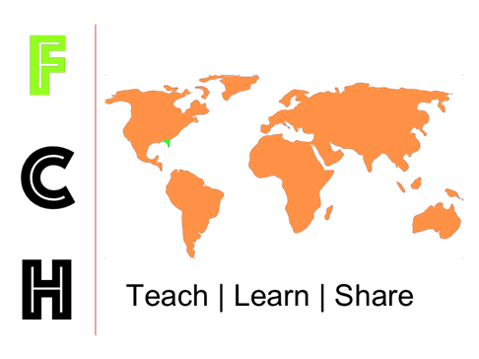

Hosted by Florida Gateway College
Local Arrangements and Program Chair
Sean McMahon
Florida Gateway College

Officers of the
Florida Conference of Historians, 2020-2021

President Sean McMahon
Florida Gateway College

Presidents-Elect Richards Plavnieks and Anna Caney
Florida Southern College

Treasurer Jesse Hingson
Jacksonville University

Secretary David Proctor
Tallahassee Community College

FCH Annals:
The Journal of the Florida Conference of Historians
Senior Editor
Michael S. Cole
Florida Gulf Coast University

Thursday, February 27
5:00 p.m. – 8:00 p.m.
Conference Welcome
Halpatter Brewery: 264 NE Hernando Avenue, Downtown Lake City
On-site registration available.
Registered attendees can pick up conference packets.
Relax with a locally brewed beer or a non-alcoholic beverage.
Hors d'oeuvres available.

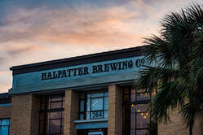

FINDING GUIDE
The plenary session will be Friday afternoon from 12:45 p.m. to 2:00 p.m. in the Wilson S. Rivers Library, Room 153. Posters and display vendors will be displayed in the library lobby.
All other panels will be in Building 2 or in Building 4.
>Hangout rooms will be in Building 4 / Room 27 and in Building 2 / Room 4. These will be places to re-charge, chat, and step away from the conference.
Lunch on Friday and on Saturday will be served in Pine Square which is the covered picnic area adjacent to Buildings 2 and 4.
PANEL ROOM LOCATION
A Building 2, Room 15
B Building 2, Room 13
C Building 2, Room 2
D Building 2, Room 3
E Building 4, Room 28
F Building 4, Room 30/31
G Building 4, Room 24
H Building 2, Room 4 (@Saturday only)
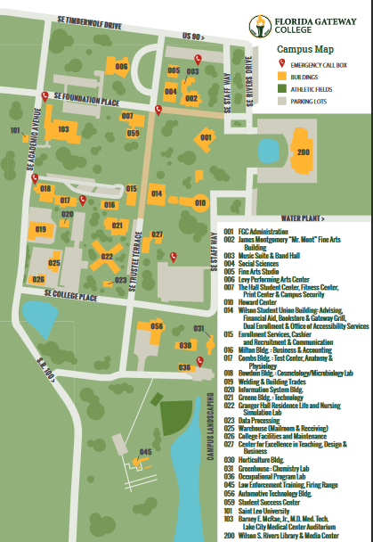
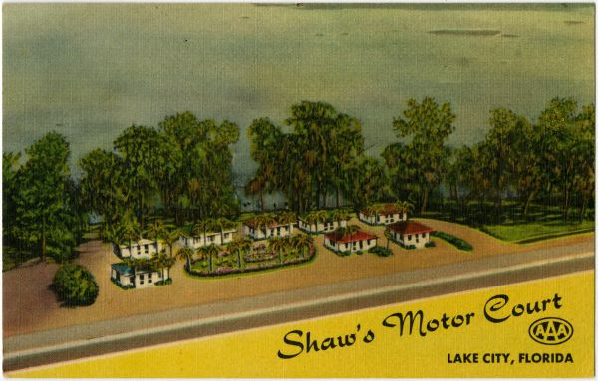
DAY 1: Friday, February 28, 2020
8:00 a.m. – 4:30 p.m. Registration. Lobby of Building 2. Coffee provided.
Book and vendor displays in Building 2 lobby.
8:30 – 9:45 a.m. Session One
10:00 – 11:15 a.m. Session Two
11:30 – 12:30 p.m. Lunch Break: Available in Pine Square. FCH Officers will meet in the Building 2
Conference Room (Room 16).
12:45 – 2:00 p.m. Plenary Session. Wilson S. Rivers Library
Poster displays in the lobby.
Documentary film screening in Room 153.
2:15 – 3:45 p.m. Session Three
4:00 – 5:15 p.m. Session Four
6:00 – 9:00 p.m. Conference Banquet. Holiday Inn Lake City -- 213 SW Commerce Dr, Lake City, FL. Cash bar.
Presentation of FCH Awards
Preview of 2021 FCH
Keynote Address
Dr Matthew Gallman, University of Florida
"When is Dissent Really Treason? Clement Vallandigham, Chauncey Burr, and the Civil War Copperheads"

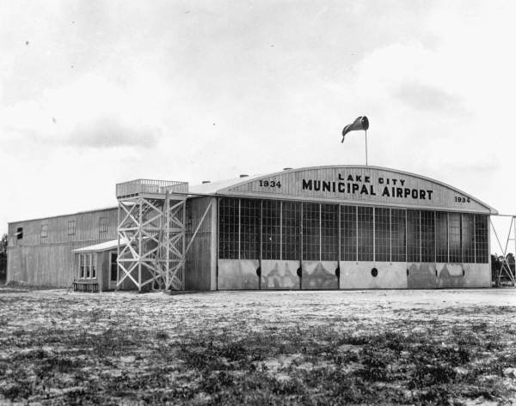

DAY 2: Saturday, February 29, 2020
8:00 a.m. – 3:00 p.m. Registration. Lobby of Building 2. Coffee provided.
Book and vendor displays in Building 2 lobby.
8:30 – 9:45 a.m. Session Five
10:00 – 11:15 a.m Session Six
11:30 a.m. – 12:30 p.m. Lunch Break: Available in Pine Square.
12:30 – 1:45 p.m. Session Seven
2:00 – 3:15 p.m. Session Eight

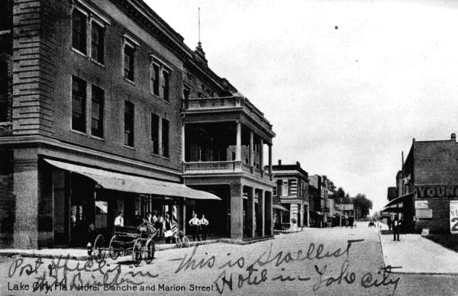

FRIDAY, FEBRUARY 28
1A The Women’s Movement in Modern America

Bonnie Ernst, University of Florida, ‘Who is this girl and what is she to you?’: The Influence of the Women's Movement in Criminal Justice Reform

Rhiannon Callahan, Florida Atlantic University, The Equal Rights Amendment and U.S. Foreign Relations: The Politics of Gender Equality on the Cold War Home Front

Kathryn Patterson, Abraham Baldwin Agricultural College, Florida's ERA Produce: ‘Oceans, White Sand, Orange Juice and Anita Bryant’

Chair/Commentator: Mary Elizabeth Rogers,
Florida Gateway College

1B Early Modern Britain
Anna Caney, Florida Southern College, Henry Howard and the Process of Persuasion: The Will to Write in the Sixteenth Century
Pádraig Lawlor, Saint Leo University, East Anglican Preservation: The Necessity of Religious Liberality in Cromwellian England
Chair/Commentator: Michael Baker, Florida Gateway College

1C The Civil War

Mariana Kellis, University of Central Florida, Elizabeth Van Lew: Spymaster for the Union in the Civil War South

R. Gregory Lande, Independent Scholar, Phantoms of War: Florida Spiritualism in the Civil War Era

Timothy Cotton, Florida State University,
‘Repugnant to Humanity’: The Custer-Mosby Feud and Reprisal in the Civil War

Chair/Commentator: Victoria Stewart, Northwest Florida State College

1D Special Interest Section: Florida History
Crime and Punishment in Twentieth Century Florida

J. Michael Butler, Flagler College,
Race, Rape, and the Death Penalty in Florida, 1925-60

Chair/Commentator: David Vaina, Union Institute and University

1E American Intellectual History

Frank Baglione, Tallahassee Community College,
‘Who Shall Rule This Country’: Jackson, T. Roosevelt and the Battle Against the Economic Elites

Ashley Steenson, University of Mississippi,
The Philosopher-Statesman: L.Q.C. Lamar, Henry Adams, and National Reconciliation

Chair/Commentator: Noah Lindsay, Florida Gateway College

1F Latin America

Michael Cole, Florida Gulf Coast University,
A Political Witch Hunt in Colonial Honduras

Daniela Aguirre, University of Central Florida, Ten Years of Spring: The Mayan Perspective of the Guatemalan Revolution

Chair/Commentator: Jesse Hingson, Jacksonville University

1G Modern Military Medicine

Laura McNiel, University of North Florida, Black & White:
The Racialization of Syphilis Treatment in British Colonial Africa

Chair/Commentator: David Proctor, Tallahassee Community College

2A Special Interest Section: Florida History
The African American Experience

David Vaina, Union Institute and University, Radical Ideas & New Faces: A History of the Black Campus Movement at the University of Florida, 1968-1975

Haley McGuyre, Independent Scholar, My Hometown has a Hidden History (And Yours Does Too): Acknowledging and Owning the Violent South

Chair/Commentator: John Paul Hill, Embry-Riddle Aeronautical University

2B Special Interest Section: Undergraduate Research
Homicide in Ocala, Florida, 1890-1915

Joshua Rivera, Florida Southern College,
Homicide in Ocala, 1895-1915

Alanya Nardone, Florida Southern College,
Homicide in Ocala, 1894-1901
Savannah A. Desrochers, Florida Southern College,
Homicide in Ocala, 1890s
Chair/Commentator: James Denham, Florida Southern College

2C Museums and Public History
Regan Nchang Che, University of Uppsala (Sweden),
The Need of Digital Archiving in Africa

Edmund Abaka, University of Miami, and George Kumasenu, Lagos State University (Nigeria), Slavery, Remembrance, and Sites of Historical Memory: The Case of Badagry

Chair/Commentator: Christine Boatright,
Director, Florida Gateway College Library

2D Special Interest Section:
Undergraduate Research/Florida History
The Legacies of Segregation:
The Not-So-Sunny History of Sunshine State Cities

Caroline Newberg, New College of Florida,
Segregation and Schools in Jacksonville

Lindsay McElroy, New College of Florida, Redlining, Segregation and Gentrification in Coconut Grove
Anna Lynn Winfrey, New College of Florida,
Gated Communities in South Florida

Chair/Commentator: Brendan Goff, New College of Florida

2E Studies in Modern Chinese History

Eike Reichardt, Lehigh Carbon Community College,
Global and Local Connections: The German Translation of Yan Phou Lee's When I Was a Boy in China

Daniel Izadirad, University of Central Florida,
Youth and State in Modern China

Daniel DuBois, Saint Leo University, For Body and Mind: Chinese Immigrants and American Sport in the Early 20th Century

Chair/Commentator: Pavel Murzhdev, Florida Gateway College

2F Special Interest Section: Florida History
Florida Before Disney:
Early to Mid-20th Century Tourism in the Sunshine State

Brian R. Rucker, Pensacola State College,
The Golden Age of Florida Tourism, B. D. (Before Disney)
Tracy J. Revels, Wofford College, Six Guns and Light Sabers: Immersion Experiences in Florida Theme Parks

Chair/Commentator: Dave Nelson, ABAC at Bainbridge

2G Special Interest Section: Scholarship of Teaching and Learning
The Advising and Mentoring Borderlands: Student Success in the 21st Century through Mentoring, Tutoring, and Professionalization

Amanda Snyder, University of Central Florida,
Labs and Coaches: Developing Undergraduate Tutors and High Impact Practice Experiences
Joseph Orser, Lecturer and Global Engagement Coordinator, University of Florida, Mentoring Gone Global: Using International Experiences to Spark Student Research, Service and Success
Patricia Farless, University of Central Florida,
‘Living the Dream’ as a Community in the Cloud:
Meaningful Advising for the Online Student

Chair/Commentator: Martha Brenckle,
University of Central Florida

Lunch will be available in Pine Square on the FGC campus.
11:30–12:30 p.m.: FCH Officers will have their luncheon in the Building 2 Conference Room (Room 16).
12:45–2:00 p.m.: Wilson S. Rivers Library
Plenary Session. Coffee and dessert provided.
>Posters on display in the library lobby. Meet the poster creators. Judges will evaluate these projects. Winner will be announced at the banquet.
Poster Presentations:
Timothy Cole Hale, Georgia State University, Slouching Towards Atlanta: How Christianity Shaped Atlanta's Counterculture

Alexis Matrone, University of West Florida,
Horror and Beauty: The Narváez Expedition

Sydnee Hammond, University of West Florida,
Cacao: The Driving Force of Mesoamerica

Matt Patsis, University of Central Florida, Chronicling Colonial Armies: An Analysis of American Newspaper Coverage of the Tirailleurs Sénégalais during World War I

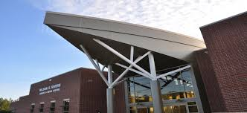
>1:00 – 2:00: “Marching Forward” documentary film screening. Room 153 of the library. Robert Cassanello from UCF will introduce the film and answer questions afterwards.
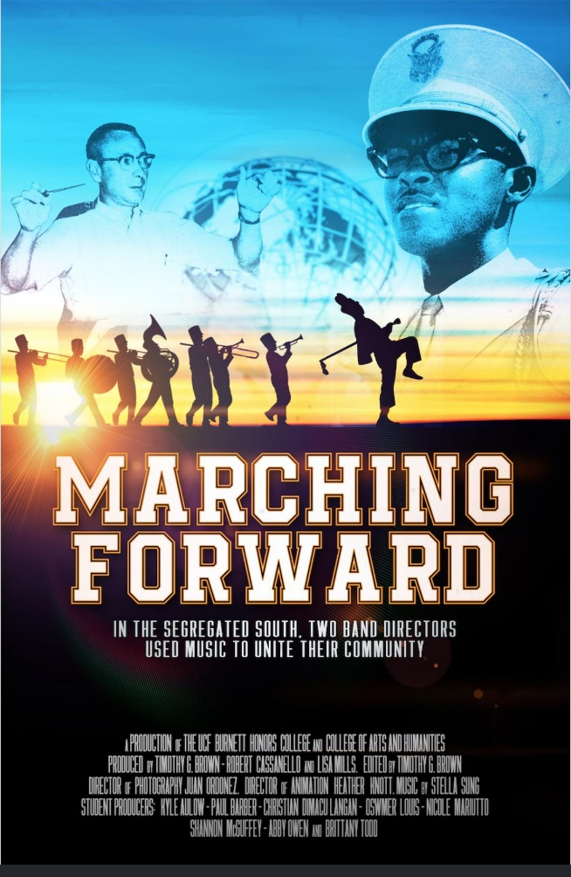

2:15 – 3:30 p.m.
3A The Civil War and Reconstruction

Tim Dorsch, University of Central Florida,
Political Cartooning Strategy During the Election of 1876

Erin Mauldin, University of South Florida-St Petersburg, Military Occupation and Land Use Change
in the Post-Civil War South

Victoria Stewart, Northwest Florida State College,
The Civil War From Within: How Desertion Plagued Florida during the American Civil War

Chair/Commentator: Harry Joiner, President,
Lake City-Columbia County Historical Museum

3B Special Interest Section:
Undergraduate Research/Media, Arts, and Culture
Studies in Music

Rose Mack, New College of Florida, ‘Please Hello,’ West is Back: History and Pastiche in the Song ‘Please Hello’ From Stephen Sondheim's Pacific Overtures

Chair/Commentator: Tina Allen, Florida Gateway College

3C Special Interest Section: Florida History
Florida Tourism

Megan Herring, Florida Southern College,
Disney's Do's and Don'ts: Has the Company Remained Faithful to Walt's Original Plan for Florida?

David Trevino, Donna Klein Jewish Academy, Who Else Wants to Know the Mystery Behind the Florida Skunk Ape?

Steven Garcia, University of North Florida, Monster and Mascot: The Alligator and Florida's Coming of Age

Chair/Commentator: Sean McMahon, Florida Gateway College

3D Special Interest Section:
Scholarship of Teaching and Learning in History
Partnering to Support K-12 History Education

Stacy Skinner, Bureau of K-12 Student Assessment, Florida Department of Education, Call for Content Experts; Supporting the U.S. History End-of-Course (EOC) Assessment

Tammara Purdin, Florida Council for History Education,
Foster Historical Mindedness and Intellectual Rigor in K-12 History Education

Chair/Commentator: Jesse Hingson, Jacksonville University

3E Studies on the Antebellum Frontier

Douglas Benner, University of South Florida, Union Jack on the Texas Frontier: How Suspicions of an Alleged British Conspiracy Influenced the Annexation Movement in the South

Kristin Miller, University of Cincinnati,
‘I was sure you would think well of Turnbull’: Governance and Animosity in British East Florida

John Ellisor, Columbus State University,
Savannah Jack Hague, the First Seminole War, and the American Conquest of Spanish Florida

Chair/Commentator: David Morton,
University of Central Florida

3F Special Interest Section: Media, Arts, and Culture
Superheroes and Graphic Media

Julian Chambliss, Michigan State University,
Understanding the Comic Imaginary: Publishing, Locality, and Identity in U.S. Comics

Thomas Donaldson, Florida Southwestern State University, ‘This Looks Like A Job for Superman!’: Superman's Transmedia Deployment and the Birth of the Superhero Genre

Chair/Commentator: Denise Johnson, Florida Gateway College

3G Dealing with Deviance in Twentieth Century America

Kaitlyn Muchnok, University of Florida,
Desegregating Delinquency: Florida’s Female Juvenile Justice System, 1945 to 1970
Meagan Frenzer, University of Florida, Undercover & Out of Step: Monitoring and Reforming Chicago’s Dance Halls, 1920s
Brandon Jett, Florida SouthWestern State College, 'Due His Utmost to Help the Police Locate the Guilty Parties': African Americans and the Police in Black Theft and Burglary Cases, 1920-1945
Chair/Commentator: Paul Renfroe, Florida State University

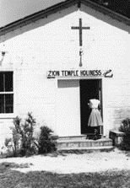

4A World War II

Steven Nicklas and Jonas Kauffeldt, University of North Georgia, Posted Where Needed: The German Reserve Officer System of World War II

Jacob Edwards, Florida Southwestern State College, Freikorps: The Forgotten Soldiers of The Weimar Republic and The Vanguards of The Third Reich

Michael Losasso, University of South Florida, Not the Russian Front: The Changing Image of the Eastern Front on American Television

Chair/Commentator: Jonathan Friedman,
West Chester University

4B Mid-Century Conflict and Social Theory

Kazuo Yagami, Savannah State University,
US-Japan Relations in the Post Cold War Era

Nicholas Iorio, University of North Florida,
Currents of Deconstruction

Jean Howell, Florida Southern College, Power, Structure, and Genius: Frank Lloyd Wright versus Le Corbusier

Chair/Commentator: David Proctor,
Tallahassee Community College

4C Special Interest Section: Undergraduate Research
The 17th Century

Sarah Bliss, Florida Southern College, Subversive Power in the Lives of Marguerite de Navarre, Catherine de Medici, and Diane de Poitiers

Taylor Martindale, Florida Gulf Coast University,
French Corsairs in the Caribbean (1522-1560)

Chair/Commentator: Pádraig Lawlor, Saint Leo University

4D Africa and the Spiritual World:
Religion, Ritual, and Revival through Colonial Influence

Brayden Lacefield, Florida Southern College, Power in the Blood: Inside Billy Graham's Crusade to Crucify Apartheid

Saneena Anzalone, Florida Southern College, Christianity and Colonial Rule: The Impact of Christian Missionaries on the Azande
Savanna Tozzolo, Florida Southern College, The Right to Ritual: Maintaining Rites of Passage under European Rule

Chair/Commentator: Anna Caney, Florida Southern College

4E Special Interest Section: Florida History
Remaking Florida: Fashion, Tourism, and Endangered Panthers

Kimberly Voss, University of Central Florida,
Fashioning Florida: Documenting Newspaper Clothing Coverage in the 1950s and 1960s

Leslie K. Poole, Rollins College, Harriett Beecher Stowe and the ‘Fairy-Land’ of Florida’s Ocklawaha River
Patrice Kohl, University of Central Florida, Modernizing the Genetic Rescue of Wildlife: From Mixing Populations to Genetic Engineering

Chair/Commentator: Steven Noll, University of Florida

4F Special Interest Section: Florida History
Studies on the History of the Seminoles

Loneise Thomas, University of North Florida, The Florida Seminoles: Sustaining Their Tribe Through Tourism

Chair/Commentator: Michael Cole,
Florida Gulf Coast University

4G Modern American Politics

John Paul Hill, Embry-Riddle Aeronautical University, The Jackie Robinson Letter: The Untold Story of the 1955 Kentucky Democratic Gubernatorial Primary

Constantinos Scaros, Lebanon Valley College/St Petersburg College, How to Teach about the 2020 Presidential Election

Chair/Commentator: Seth Weitz, Dalton State College

FRIDAY, FEBRUARY 28, 2020
FLORIDA CONFERENCE OF HISTORIANS
BANQUET
HOLIDAY INN LAKE CITY
213 SW Commerce Drive, Lake City FLA

5:30–6:30 p.m.
Cocktails and light snacks available – cash bar
6:30 p.m.
Welcome Banquet
FCH Awards
Introduction of FCH President and preview of 2021 Conference
Keynote speaker: Professor Matthew Gallman, University of Florida
"When is Dissent Really Treason? Clement Vallandigham,
Chauncey Burr, and the Civil War Copperheads”

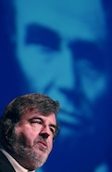
SATURDAY, FEBRUARY 29, 2020
8:00 a.m. Registration in Building 2 Lobby. Coffee provided
5A Special Interest Section: Media, Arts, and Culture
Film Studies

Felicia Bevel, University of North Florida, The Birth of a Nation Outside of the Nation: Romanticizing the Old South in Australia

David Morton, University of Central Florida, “That the 'Traditions of the South' and 'Pure Americanism' Shall be Perpetuated”: The Influence of the Ku Klux Klan and Prohibition Party on Florida's Silent Motion Picture Industry

Jonathan Friedman, West Chester University,
Representing Genocide in Five Recent Feature Films

Chair/Commentator: David Hurner, Florida Gateway College

5B Special Interest Section: Undergraduate Research
20th Century Women’s Studies

Isabel Hidalgo, Florida Atlantic University, Mrs. Forman Shot the Alligator: How South Florida Women Pioneers Built Community in the Late 19th and Early 20th Centuries

Diana Proenza, New College of Florida,
Redefining Womanhood in the Age of Industrialization: Women's Magazines and Modernism

Chair/Commentator: Patricia Farless,
University of Central Florida

5C The Bible and Religion

J.D. Reiner, Florida Atlantic University,
The Textual Evidence, Social Context, and Archaeology Behind Jesus' Exorcism Near Tyre

Patrick Luck, Florida Polytechnic University, Race, Gender, and Civilization on the Coast of Africa: Presbyterian Missionaries in Colonial Liberia

Emily Young, Florida Southern College,
The Influence of Religion on Supreme Court Decisions Regarding Reproductive Rights

Chair/Commentator: Troy Appling, Florida Gateway College

5D Island Nationalism

Jason Ratcliffe, Florida State University, Historiography and the Problem of Nationalism: A Philippine Case Study

Christopher Dingler, Florida Atlantic University, Changing Tides: Hawaiian Annexation, Trans-Pacific Rivalry, and American Empire

Christopher Williams, University College of the Cayman Islands, Between a Past and Present Consciousness: Accounting for the Effects of Jamaica on the Nationalist Caymanian Consciousness

Chair/Commentator: John McTague, Saint Leo University

5E Special Interest Section: Florida History
Florida Legal History

Paulo Henrique Rodrigues Pereira, University of Sao Paulo (Visiting as FAS Harvard), The Free Womb Concept in America: Law and Slavery in a Continental Perspective

Craig Buettinger, Jacksonville University, Laws, Loans, and the Free Blacks of Late Antebellum Jacksonville

James M. Denham, Florida Southern College,
Captain Charles E. Hawkins, The 'Key West Tragedy', and the Unwritten Law, 1827-1830

Chair/Commentator: Claire Strom, Rollins College

5F Special Interest Section: Undergraduate Research
Punishment, Propaganda, and Pandora’s Box: The Making of the American State

Garrett Lischke, Saint Leo University, The Plight of Justice: The Philosophical and Historical Origins of America’s Prison Systems

Daniel Scott, Saint Leo University, Disney and Dr. Seuss at War: Media and Propaganda During World War II

Douglas ‘Andrew’ Smith, Saint Leo University, Opening Pandora's Box: The United States and Iraq, 1999-2003

Chair/Commentator: Dan DuBois, Saint Leo University

5G Violence on the Land:
Invasive Species and Unnatural Disasters

Andrew Pemberton, University of North Florida,
Invading Eden: Exotic Pets and Invasive Species in South Florida
Chau Johnsen Kelly, University of North Florida,
'Bewildered and hopeless in a town of chaos:' From Colonial to Neo-Liberal Natural Disasters in East Africa
Alison J. Bruey, University of North Florida,
The Devil Came Down to Chillán: Earthquakes and Popular Knowledge in Modern Chile
Chair/Commentator: Charles Closmann,
University of North Florida

6A The Interwar Period in North America

Katherine Ryan, Florida Gulf Coast University, Native American Motivations for Participation in the World Wars

Margaret Stewart and Claire Strom, Rollins College,
Farmers to Chauffeurs: African American Employment during the Interwar Years in Hannibal Square, Florida

Heribert von Feilitzch, Independent Scholar, The Canadian Parliament Fire of 1916: A Severely Flawed Investigation

Chair/Commentator: Danielle Wirsansky, Independent Scholar

6B Modern South Asian politics
Shalala Mammadoua,
Azerbaijan Tourism and Management University,
Political Orientation and Ethnic Identity in Modern Azerbaijan

John McTague, Saint Leo University,
Kashmir: The Next Palestine?

Chair/Commentator: Jesse Hingson, Jacksonville University

6C Gender and Social Theory

Sarah Lane, New College of Florida, Sacrifice and Strength: The Representation of Women in Italian Fascist Visual Propaganda

Elizabeth Littell-Lamb, University of Tampa,
‘The Door is Open that No Man Can Shut’: Engendering Women’s Identity as Modern in Republican China, 1915-1930

Chair/Commentator: Stefan Malizia, Florida Gateway College

6D Special Interest Section: Florida History
Early Twentieth Century Florida

Andrew Kishuni, University of Central Florida, ‘You Are A Menace To Others’: The Historical Epidemiology of Mortality in the Influenza Pandemic in Jacksonville, Florida, 1918-1919

Andrew Huse, University of South Florida Libraries,
The Sawdust Trail: Rev. Henry Stough Takes on Corruption in Tampa, 1916

Thomas Castillo, Coastal Carolina University, Florida's Tom Watson, New Deal Populism, and the Right to Work

Chair/Commentator: Seth Weitz, Dalton State College

6E African American Studies

Zafirios Daglaris, University of Central Florida, Materiality, Enjoyment, and the Minstrel Legacy
of Sentimentalism

Ricardo De La Espriella, Florida Atlantic University, Integration's Shortcomings

Emma Posca, York University, Resistance Through Ethnographies: Connections to Allyship for Black and Indigenous Women in a North American Context

Chair/Commentator: Julian Chambliss,
Michigan State University

6F The Cold War

Cristian Delorey, Florida Southern College,
Birds of Prey: An Analysis of U.S. Involvement in & Logistical Support of Operation Condor

Nicholas Eidenschink, Florida Southern College, General Van Fleet And The Lack of The 'Will to Win' in Florida

Chair/Commentator: Mike Epple, Florida Gulf Coast University

6G Special Interest Section: Florida History
Florida Environmental Studies

John D. Wineland, Southeastern University, A Report on the 2018-19 Season Shell Hammock Archaeological Project

Cameron Kellerman, University of North Florida, Space and Nature: The Impact of the Space Shuttle Program on Merritt Island National Wildlife Refuge and Canaveral National Seashore

Chair/Commentator: Charles Closmann,
University of North Florida

6H Special Interest Section: Undergraduate Research
Natural and Unnatural Disasters in World History

Samantha Richter, University of Tampa,
The ‘Black Death’ and the 1381 Peasant’s Revolt in England

Elizabeth Ho-Sing-Loy, University of Tampa,
The 1666 Great Fire of London and the Concerns of John Snow

Jim Gallatin, University of Tampa, The 1812 Caracas Earthquake: Aftershocks and Revelations in U.S. Foreign Policy

Chair: Spencer Segalla, University of Tampa
Commentator: Alison J. Bruey, University of North Florida

11:30 a.m.–12:30 p.m. Lunch Break:
Available in Pine Square, Florida Gateway College

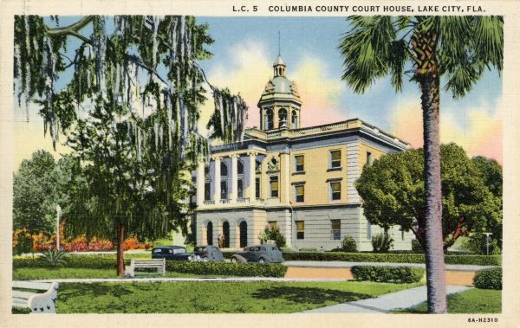

7A Culture and Foreign Conflict in the Twentieth Century

Dale Pappas, University of Miami, Between Crusaders and Friendly Invaders: Fascist Italy and Tourism Promotion in the Aegean, 1923-1940

Danielle Wirsansky, Florida State University, Desert Queen and the White Mouse: How the Successes of Everyday British Women and Female Spies in World War I Paved the Way for the Female Agency in World War II

Chair/Commentator: Marco Rimanelli, Saint Leo University

7B Special Interest Section: Undergraduate Research
Representations and Responses in the Middle Ages

Margie Freeman, New College of Florida,
The Stigmatization of Saint Francis in Art and Hagiography
Emma Claire Todd, New College of Florida, Nationalist Representations of King Henry IV and Pope Gregory VII in German Drama and Art
Emily Lovett, New College of Florida, The Allegorization of Countess Matilda of Tuscany as Deborah in Eleventh-Century Polemical Works

Chair/Commentator: Rowena J-M.H. Múzquiz,
St. Vincent de Paul Regional Seminary

7C U.S. Diplomacy toward Non-European Nations during the Age
of Atlantic Revolutions

Ileane Marquez, Texas State University,
‘The Right to Intervene’: European Non-Interference and U.S. Aggression in Latin America

Hannah Thompson, Texas State University, Standing on the Shoulder of Giants: How Early American Presidents Paved the Way for the Monroe Doctrine
Kendall Allen, Texas State University, ‘For Their Greatest Good’: Education as a U.S. Diplomatic Tool in Negotiations with Native Peoples

Chair: Margaret Vaverek, Texas State University
Commentator: Ronald Angelo Johnson, Texas State University

7D Special Interest Section: Florida History
Modern Florida

Seth Weitz, Dalton State College, ‘Quick now, who was Florida's 39th governor?’: The John Wayne Mixson Story

Dave Nelson, ABAC-Bainbridge, Dangerous Knowledge? Fear and Anxiety over Sex Education in Florida, 1968-1982

Jolita D. Wainwright, Stanton High School,
Stanton Schools: A Documentary 1868-2018

Chair/Commentator: Sean McMahon, Florida Gateway College

7E Special Interest Section: Undergraduate Research
Florida Historical Homicide Exploration, 1913-1964

Angel Holmes, Florida Southern College,
Homicide in Lakeland, Florida, 1913-1921
Shelby Brown, Florida Southern College,
Homicide in Pensacola, Florida 1913-1916

Catherine Stogner, Florida Southern College,
Murder They Wrote: Homicide in Naples, Florida, 1964
Chair/Commentator: Richards Plavnieks,
Florida Southern College

7F Politics and Culture in Modern Latin America

Austin Shutov, Nova Southeastern University, From Beirut to Barranquilla: Arab Influence on the Culture and Economy of Coastal Colombia in the 20th Century

Jesse Hingson, Jacksonville University,
Commemorating the ‘Penguin Movement’:
Teaching Social Movements in Latin America

Chair/Commentator: Jesse Hingson, Jacksonville University

7G The Cold War
Michael Epple, Florida Gulf Coast University, The Making of a Crusader: How Bishop Fulton J. Sheen came to Crusade against Communism

Jennifer Corley, San Jose State University, ‘An Amusing Insult to Princeton': The Fabrication of the Glassboro Summit, June 1967

Kathie Beebe, Florida State University, Native American and Environmental Price of Technological Innovations

Chair/Commentator: David Proctor,
Tallahassee Community College

7H Modern Biography

Joseph Clarke, Jacksonville University (Emeritus),
The Marxist Influence in Rev. J. Calvitt Clarke's Literary Fiction

Robert Kirkland, California Institute of Advanced Management, Peter Drucker and the Evolution of His Thinking on the Corporate Social Contract ‘Management as a Liberal Art’

Chair/Commentator: Joseph Clarke, Jacksonville University

8A World War II

Christopher Griffin, Brescia University, Battlefront Tourism

Augustine Meaher, Air Command and Staff College, Air University, ‘This is a business proposition, Not Peanut Politics’: Ernest Graham Wartime Lobbyist for Southern Florida

George Cressman, Jr., Camp Blanding Museum,
Camp Blanding's Enemy Alien Stockade

Chair/Commentator: David Harvey, New College of Florida

8B Special Interest Section: Undergraduate Research
Florida Historical Homicide Exploration, 1890-1925

Logan Buffa, Florida Southern College,
Homicide in Bradford County, Florida 1890-1901
Chase Robinson, Florida Southern College,
Homicide in Arcadia, Florida, 1906-1908
Catherine Hall, Florida Southern College,
Homicide in Fort Myers, Florida, 1925

Chair/Commentator: Richards Plavnieks,
Florida Southern College

8C Special Interest Section: Florida History
Environmental Impact of the US Civil War

Judkin Browning, Appalachian State University, ‘If You Can't Feed Us, You Had Better Surrender Us’: Environmental Influences on Food Shortages in the Confederacy during the Civil War

Charles Closmann, University of North Florida,
The Ecology of War: Timber, Cattle, and the Battle of Olustee

Chair/Commentator: Craig Buettinger, Jacksonville University

8D Packaging the Past: Historical Sites as Travel Destinations
Luc Houle, University of Florida, The ‘Virtual Witness’ and the Importance of Place in Medieval Provence
Larissa Neuburger, University of Florida, Augmented Reality As a Tool to Reconstruct Historic Tourism Sites

Chair/Commentator: Dominique Kirchner Reill,
University of Miami

8E Representations and Responses of the First World War

Marco Rimanelli, Saint Leo University, World War I Witness: Italy's Royal Carabiniers Captain Ettore Chiurazzi from the Italo-Austrian Front Headquarters to Post-War Allied Military Commission on the Turkish Straits

Karen Hannel, Saint Leo University, War Culture on the Silver Screen: “The Battle of the Somme (1916)"
Pádraig Lawlor, Saint Leo University, From Insurrection to Independence: The Irish Experience in World War One

Jerome Williams and Iain Duffy, Saint Leo University,
The Great Influenza Pandemic of World War I & Bio-Chemical Impact on Today’s Avian Flu Threats

Chair/Commentator: Marco Rimanelli, Saint Leo University

Make your plans now for the
2021 Florida Conference of Historians
hosted by Florida Southern College!

